STEPS FOR LAUNCHING AN INSTANCE

1.Open the Amazon EC2 console at https://console.aws.amazon.com/ec2/.

2.In the navigation bar at the top of the screen, the current region is displayed. Select the region for the instance.

3.From the Amazon EC2 console dashboard, choose Launch Instance

4. Choose an Amazon Machine Image (AMI)

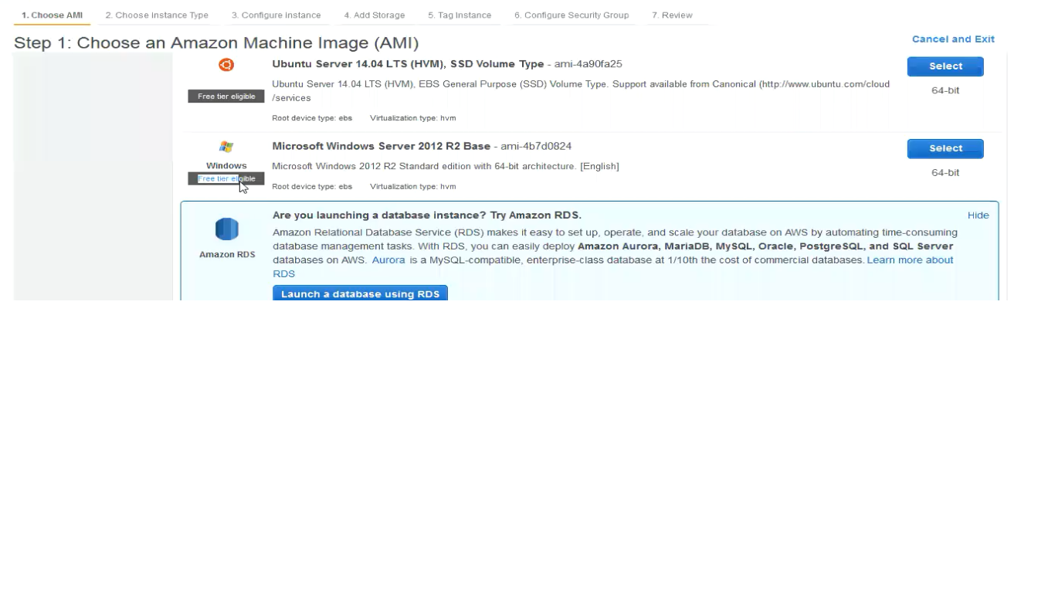

5.Check the Root device type listed for each AMI

6. Choose the t2.micro instance type

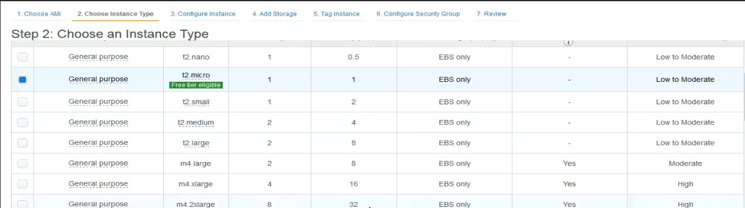

7.Choose No preference to let AWS choose a default subnet in any Availability Zone

8.Auto-assign Public IP enable

9.Enable termination protection

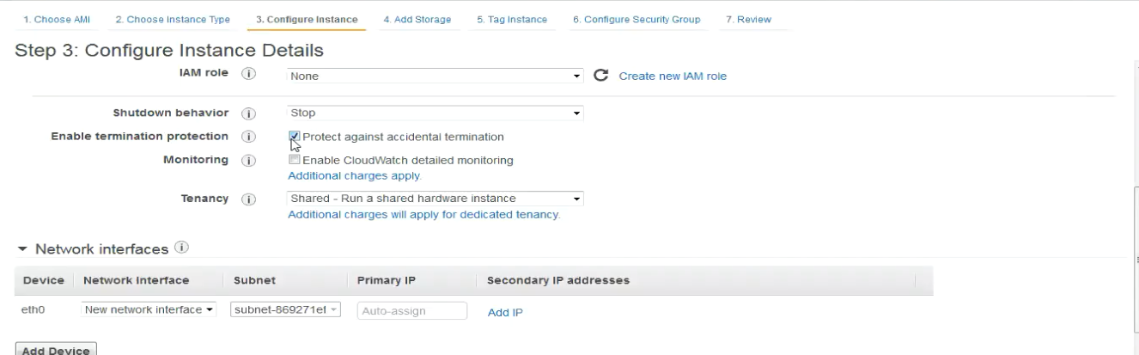

10.On the Add Storage page, specify volumes to attach to the instance besides the volumes specified by the AMI

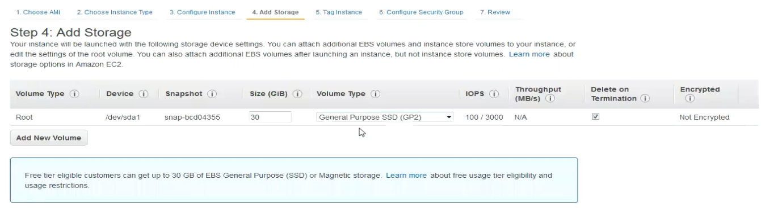

11.On the Tag Instance page, specify tags for the instance by providing key and value combinations

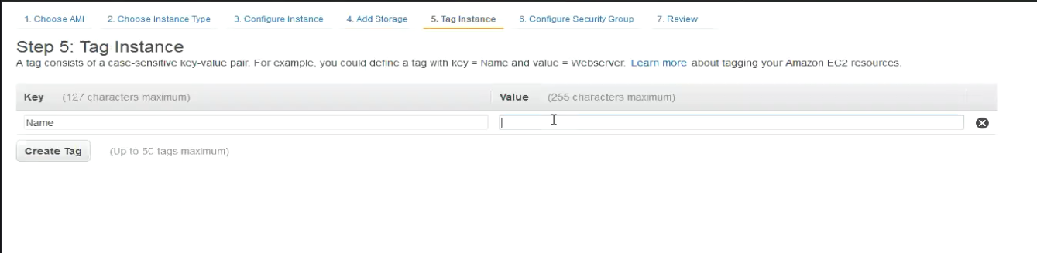

12.On the Configure Security Group page, use a security group to define firewall rules for the instance

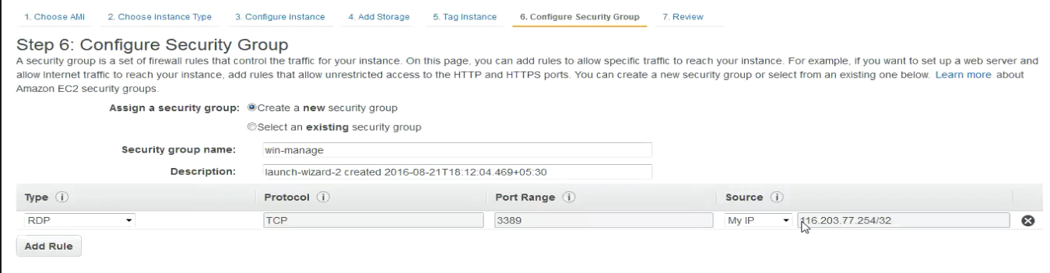

13.On the Review Instance Launch page, check the details of the instance

14.Select an existing key pair or create a new key pair dialog box, and can choose an existing key pair, or create a new one.

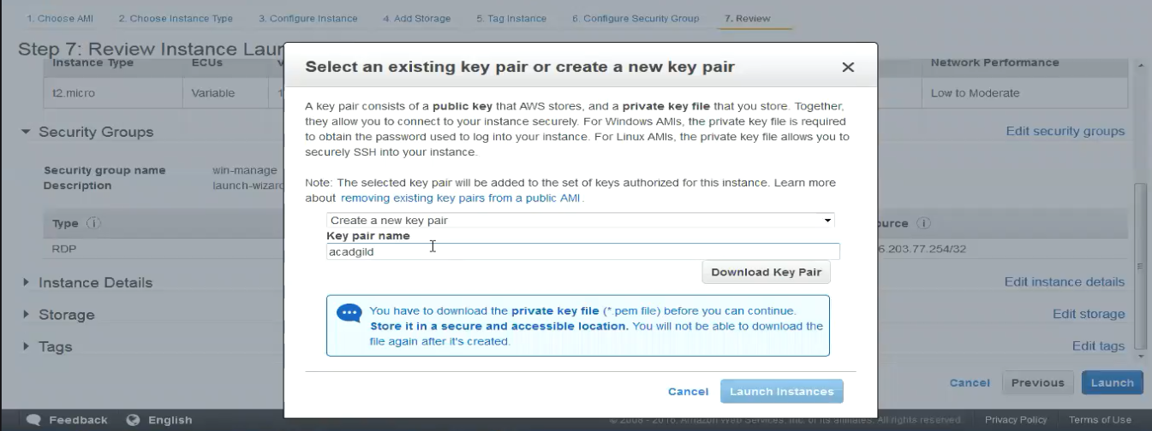

15.Connect to the AMI using ssh or RDP by the public DNS IP once the status checks are completed

